**Python and Bio-Python**

Assignment 4

Practical Solving:

1.     Write a program demonstrating declaration, accessing- Indexing and splicing of tuples and its elements.

**Algorithm**:-

Step 1: A tuple is declared by placing all the items (elements) inside parentheses (), separated by commas and assigning it to a variable.

Step 2: To access the tuple items refer to the index number insed the index operator[] (Indexing).

Step 3: By inputting a range of indexes by specifying where to start and where to end the range we can print a subset of the tuple (splicing)

Answer: Program demonstrating declaration, accessing- Indexing and splicing of tuples and its elements:

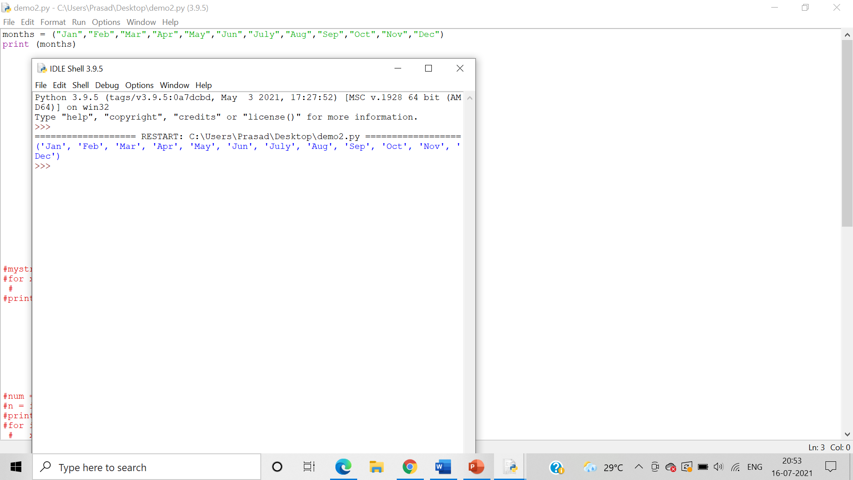

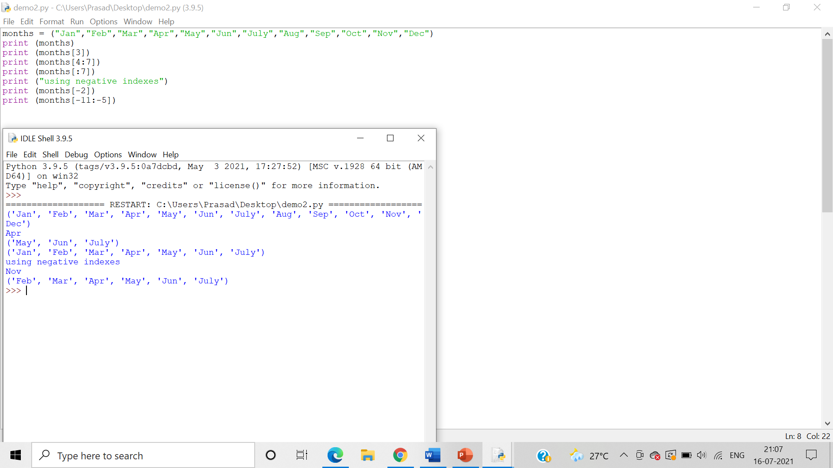

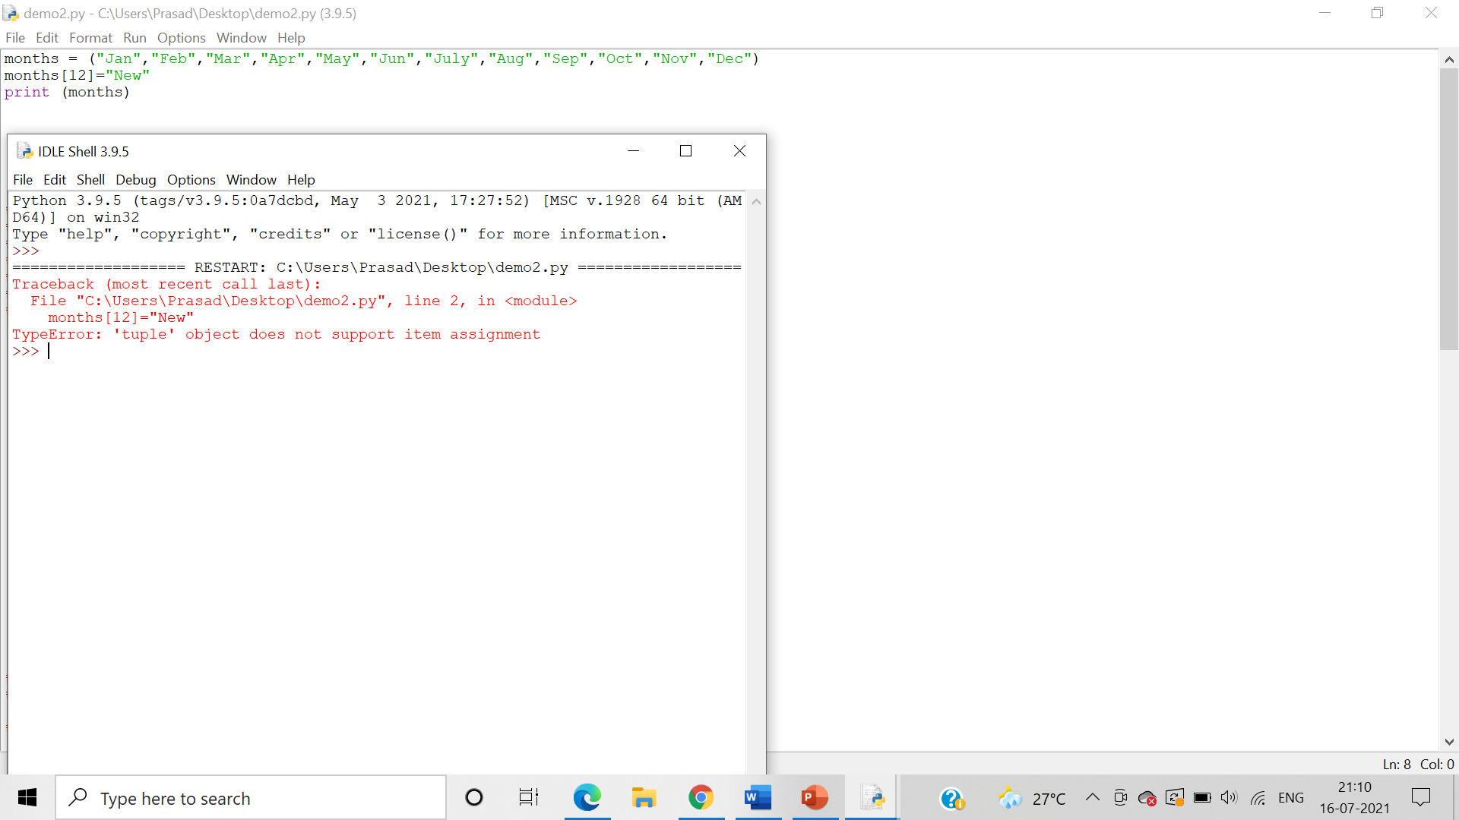

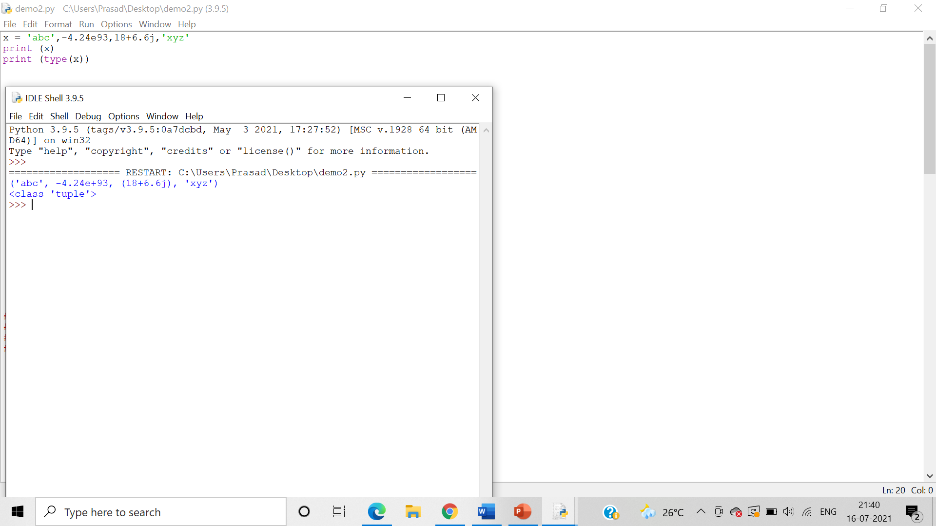

2.     Write a program demonstrating input of tuple elements from the user

**Algorithm**:-

Step 1: Use the input() function to take user input and assign it to a variable

Step 2: Use the split function to split each value in the variable with a “,” and assign it a new tuple variable.

Step 3: Print the tuple variable

Answer: Program demonstrating input of tuple elements from the user:

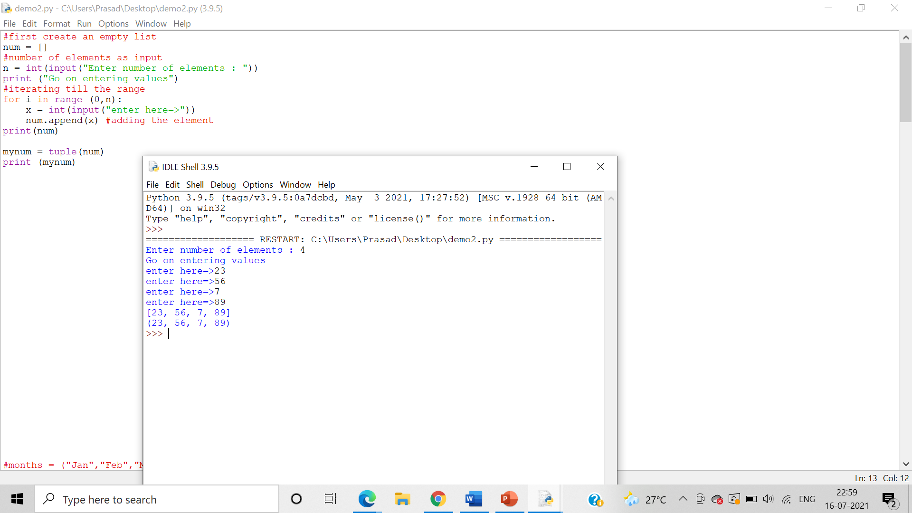

3.     Write a program demonstrating printing of tuple elements using for in and range() function

**Algorithm**:-

Step 1: Declare a tuple by assigning it to a variable

Step 2: The range() gives us a sequence of numbers in between the two integers given to it.

Step 3: We can use the in and range() function to print the tuple elements using a for loop.

Answer: Program demonstrating printing of tuple elements using “for in”:

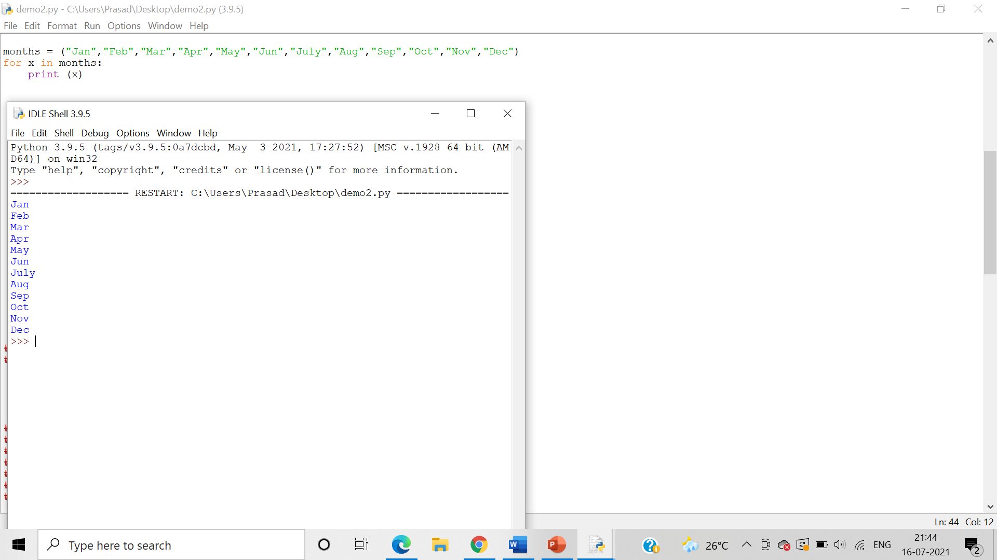

Program demonstrating printing of tuple elements using range() function:

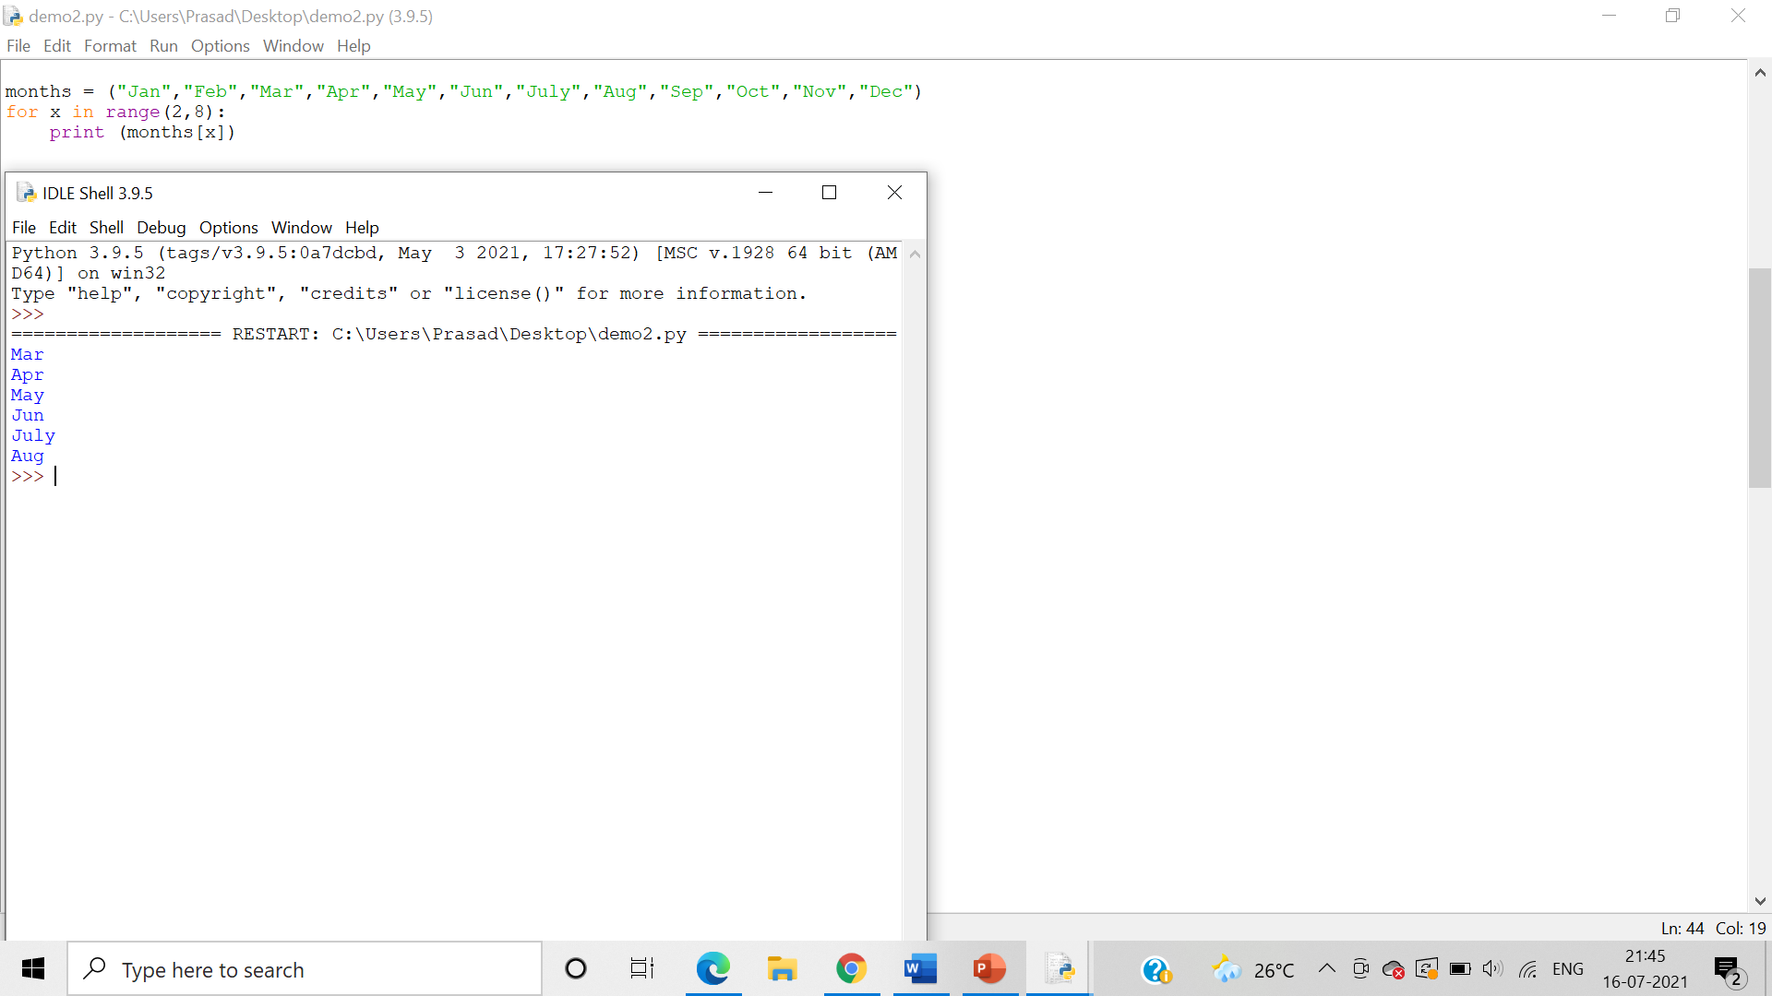

4.     Write a program demonstrating len() and del() function on tuple.

**Algorithm**:-

Step 1:   The len() function is used to obtain the length of the tuple

Step 2: The del() function **deletes all the elements in range** starting from index ‘a’ till ‘b’ mentioned in arguments.

Answer: Program demonstrating len() function on tuple:

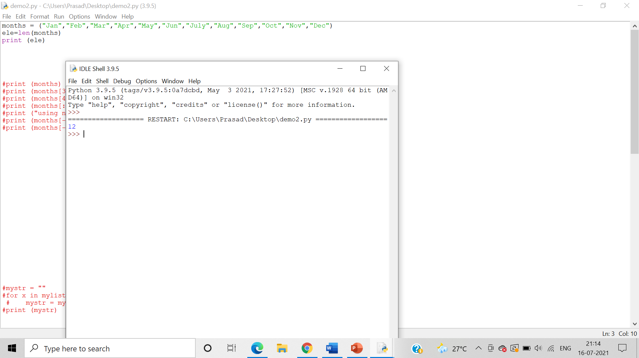

Program demonstrating del() function on tuple:

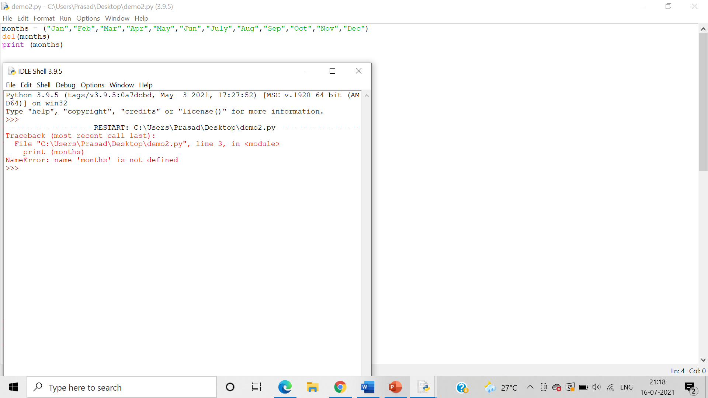

5.     Write a program demonstrating usage of ‘+’ and ‘*’ operators on tuple

**Algorithm**:-

Step 1: The ‘+’ operator is used to concatenate the 2 tuples into a single tuple.

Step 2: The ‘*’ operator is used to to**multiply the tuple “n” times**

Answer: Program demonstrating usage of ‘+’ operators on tuple:

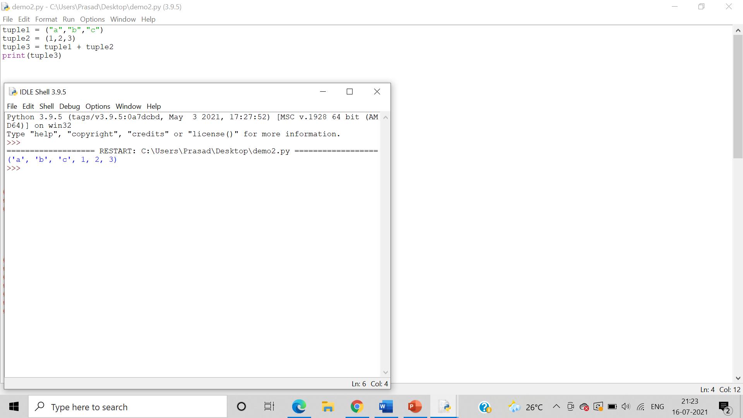

Program demonstrating usage of ‘*’ operators on tuple:

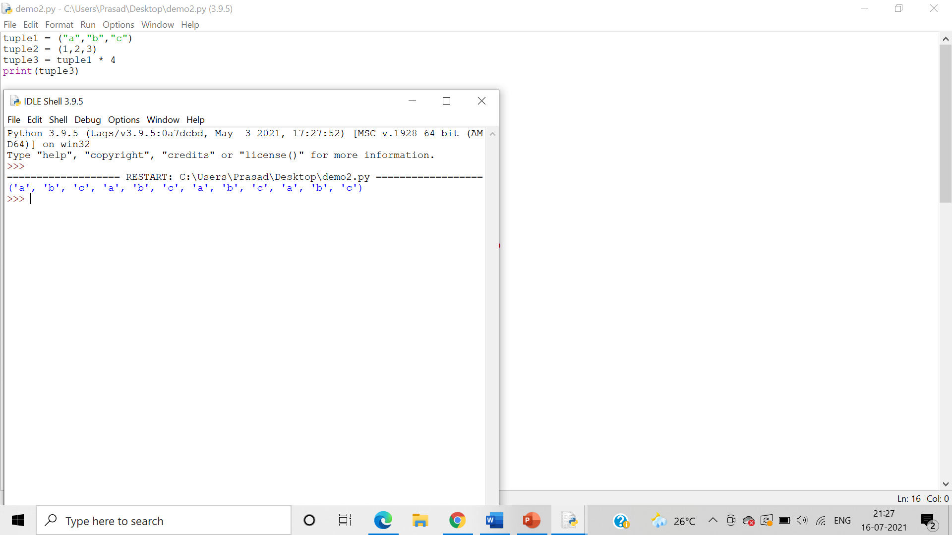

6.     Write a program demonstrating “in” and “not in” keywords on tuple

**Algorithm**:-

Step 1: - The ‘in’ operator is used to **check if an element is present** in the tuple or not. Returns true if element is present in tuple else returns false.

Step 2:  The ‘not in’ operator is used to **check if an element is not present** in the tuple or not. Returns true if element is not present in tuple else returns false.

Answer: Demonstrating “in” keyword on tuple:

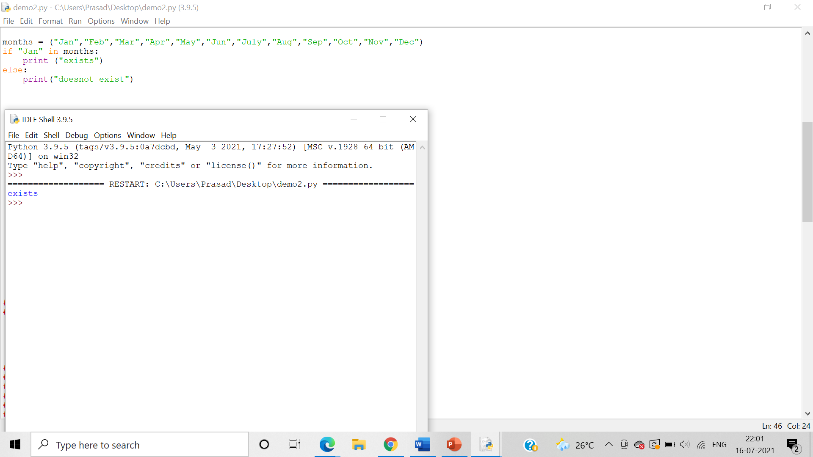

Demonstrating “not in” keyword on tuple:

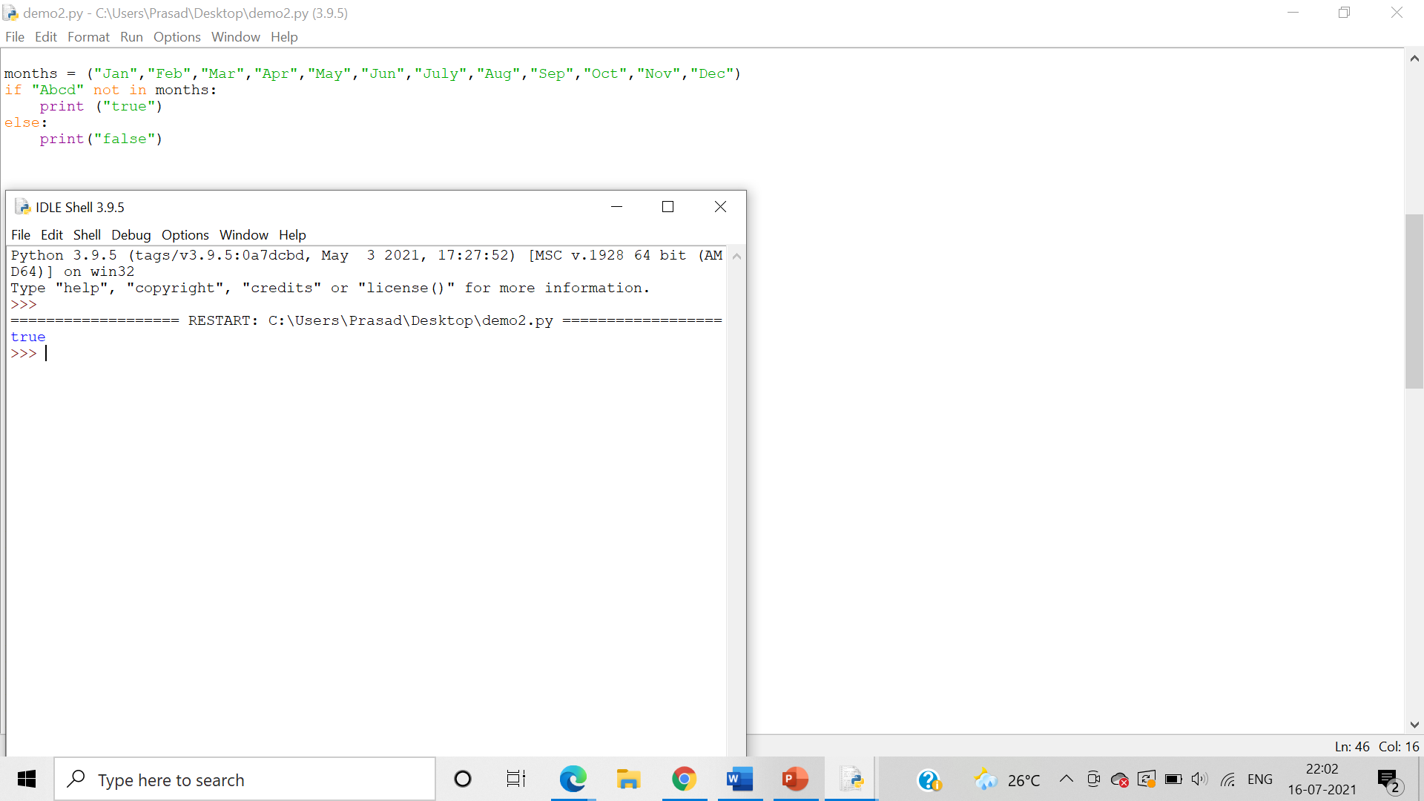

7.     Write set of programs for demonstrating the usage of all the different Tuple methods along with their variations

**Algorithm**:-

Step 1: The count() method returns the number of times a specified value occurs in a tuple

Step 2: The index () searches the tuple for a specified value and returns the position of where it was found. It raises an exception if item is not found

Answer: Programs for demonstrating the usage of count() :

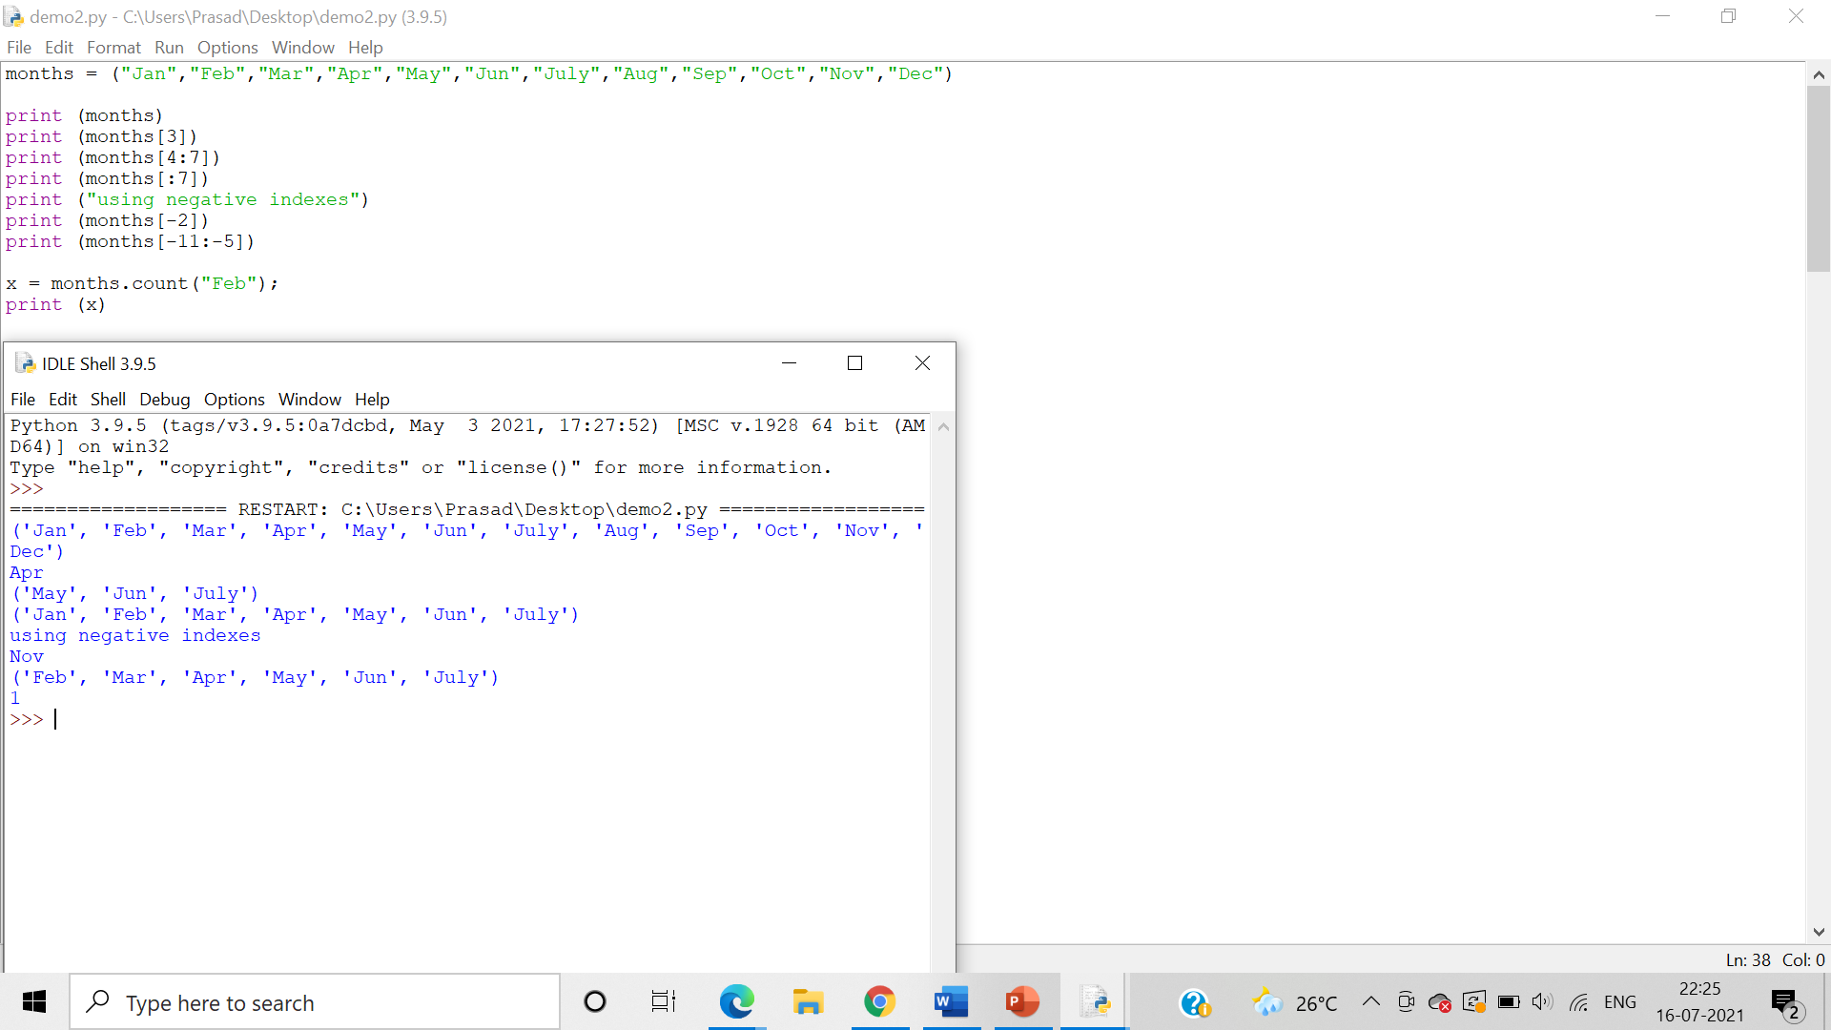

Programs for demonstrating the usage of index() :

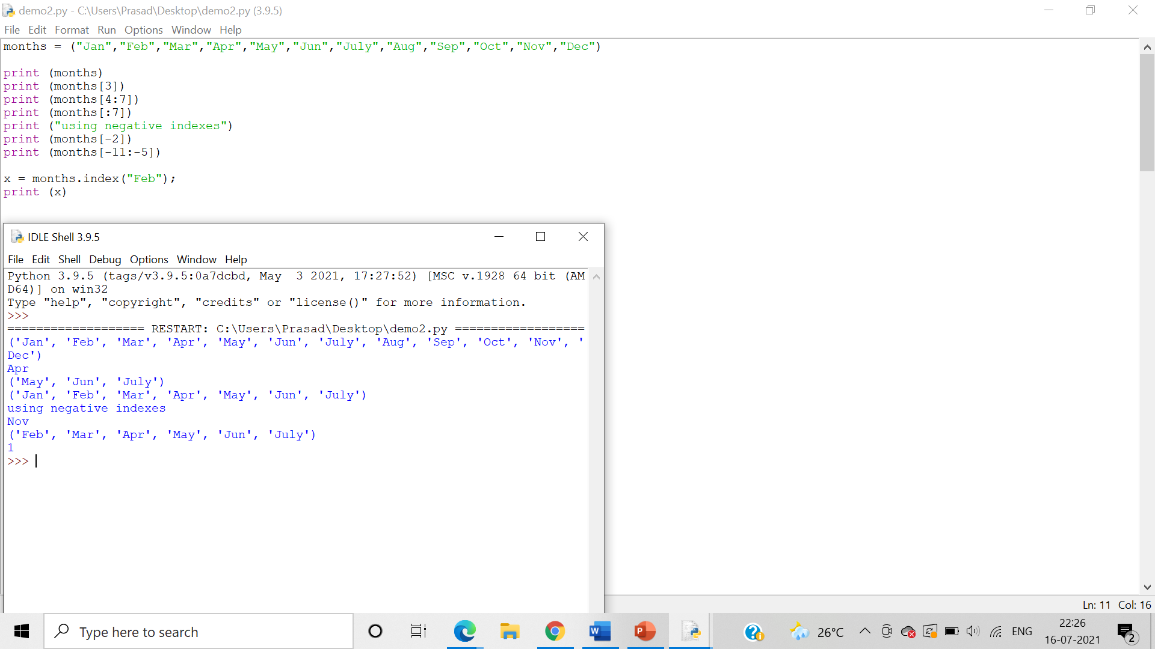

rindex() is not applicable in tuples:

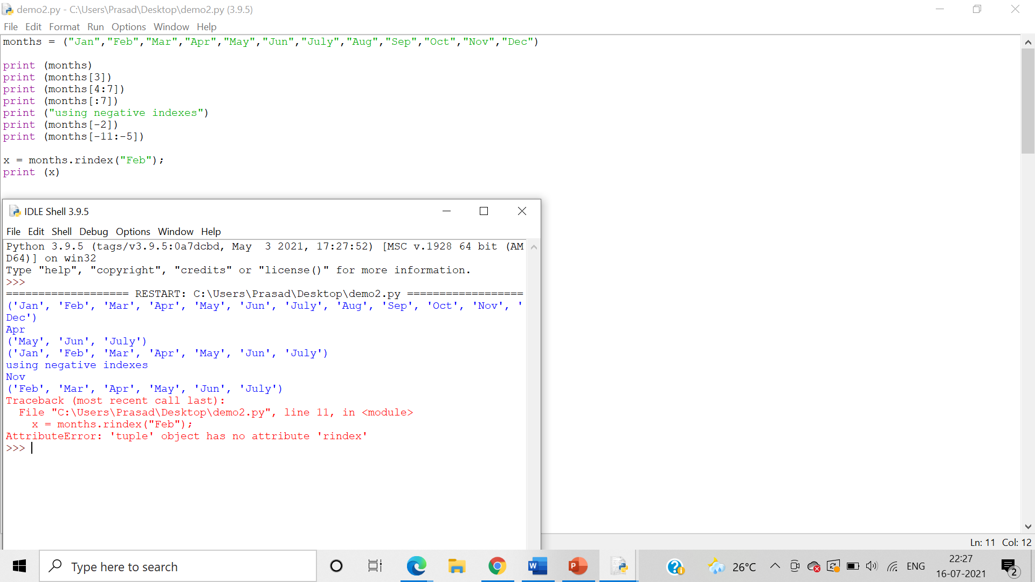

8.     Write a program demonstrating declaration and accessing of Sets and its elements.

Answer: Program demonstrating accessing of Sets:

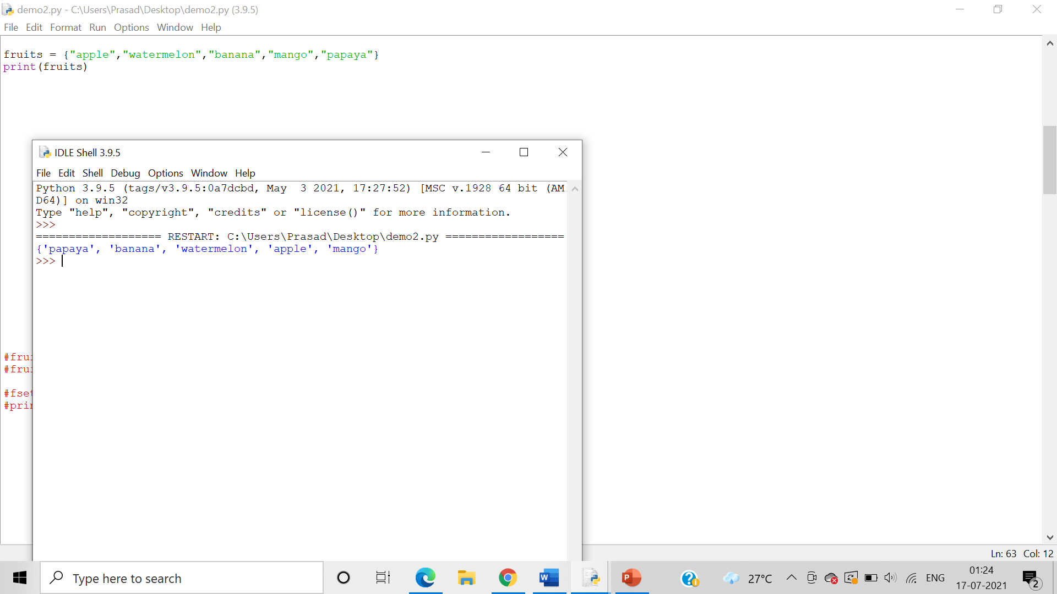

9.     Write a program demonstrating len() and del() function on Sets.

Answer: Program demonstrating len() function on Sets:

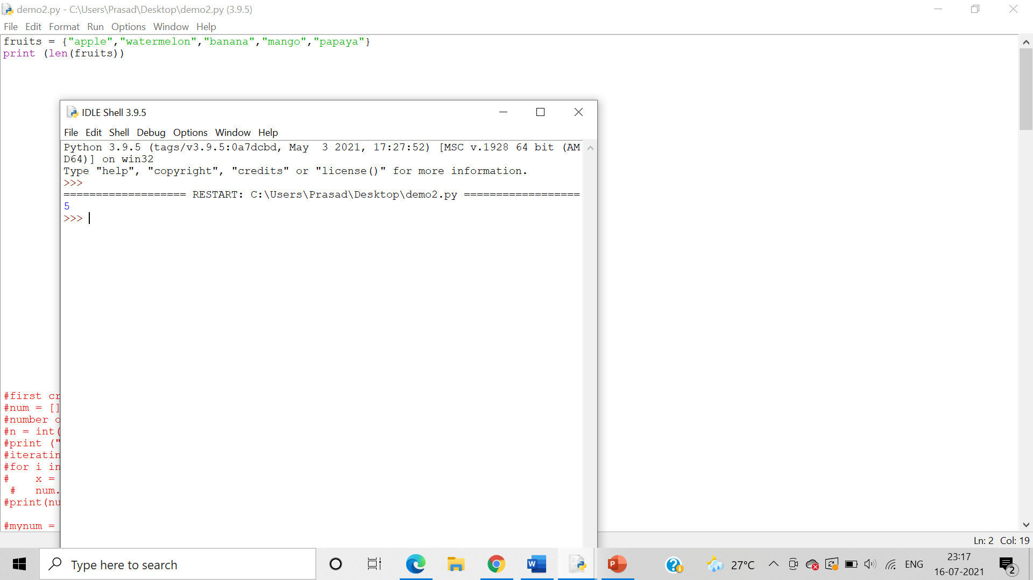

Program demonstrating del() function on Sets:

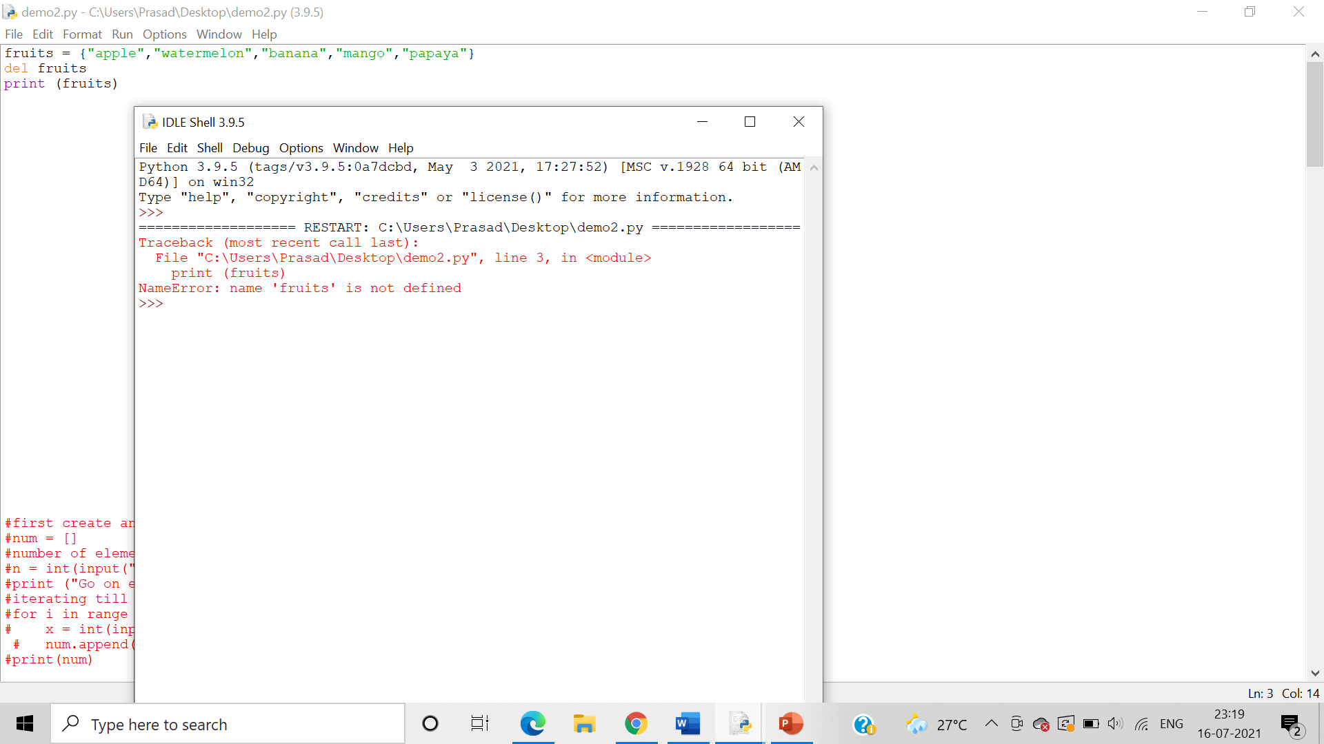

10.  Write a program demonstrating input of Set elements from the user

Answer: Program for demonstrating input of Set elements from the user

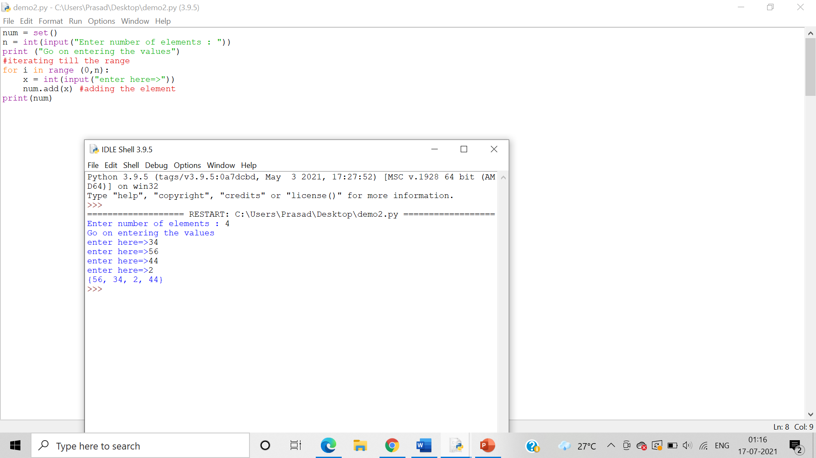

11.  Write set of programs for demonstrating the usage of all the different Set methods along with their variations

Answer: Program for demonstrating add()

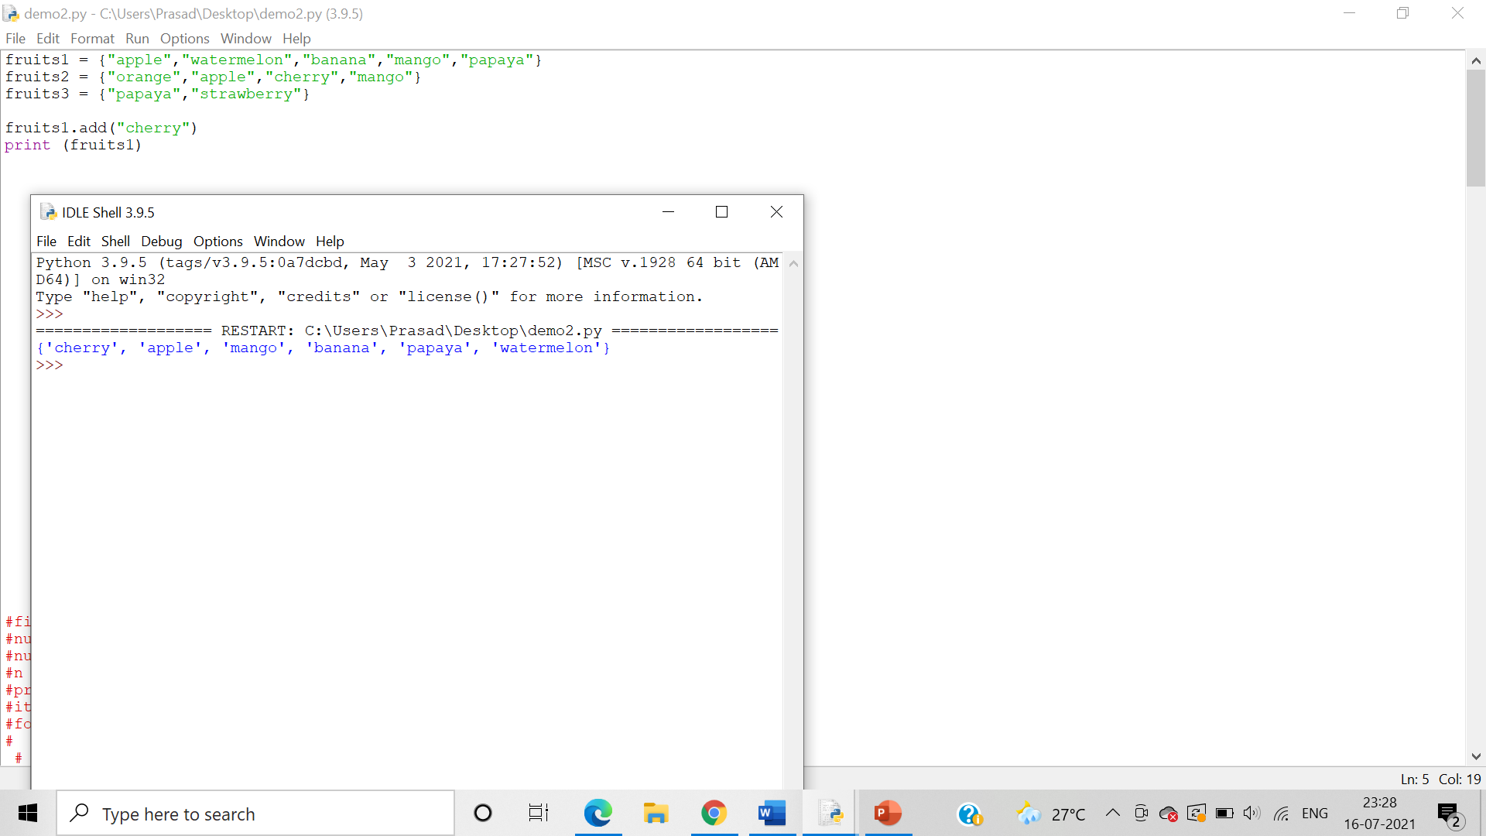

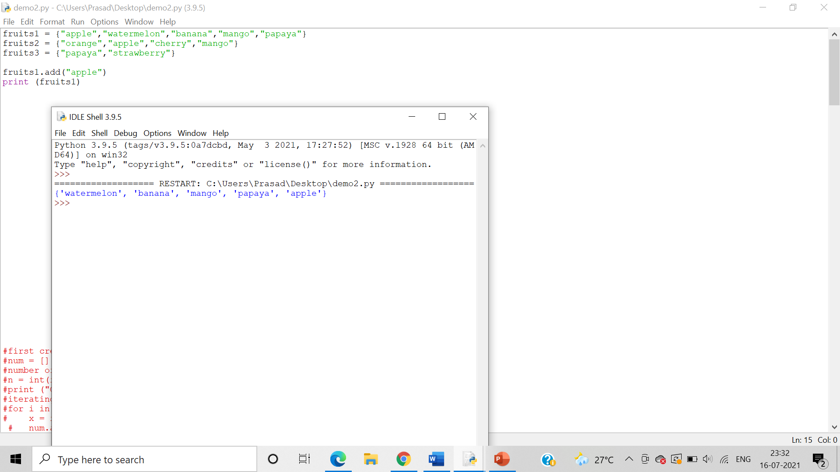

Program for demonstrating clear()

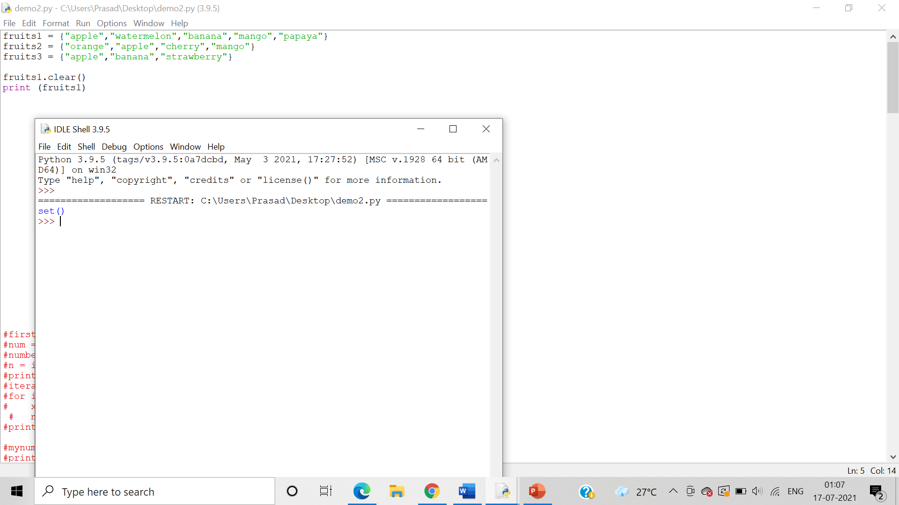

Program for demonstrating copy()

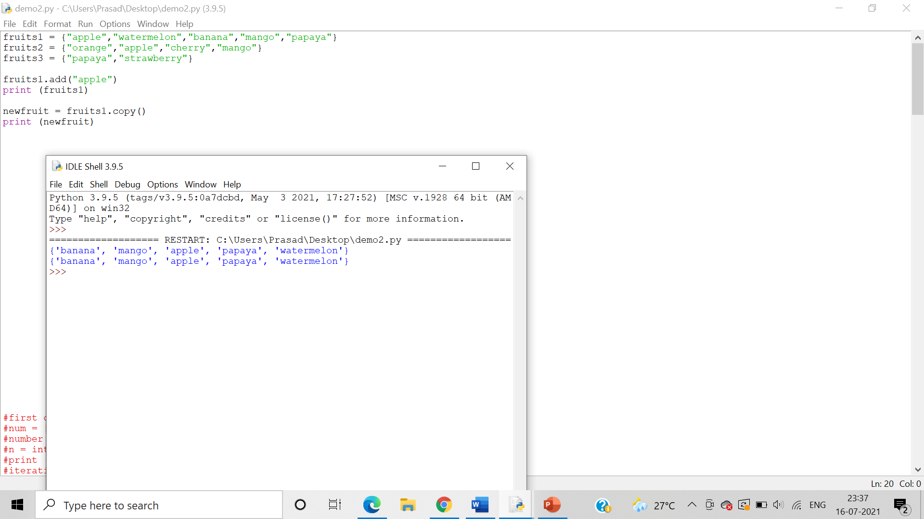

Program for demonstrating difference()

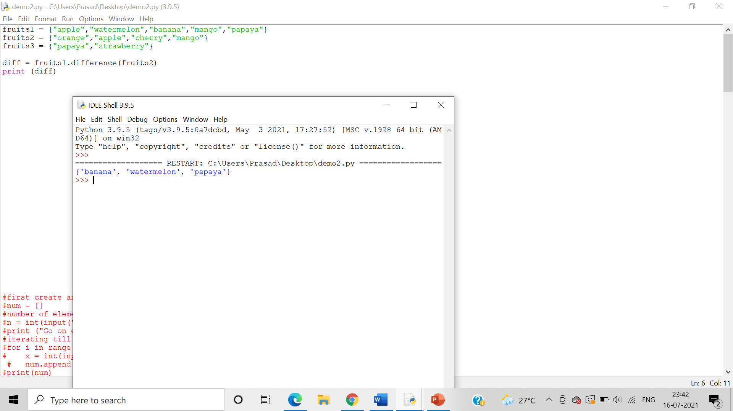

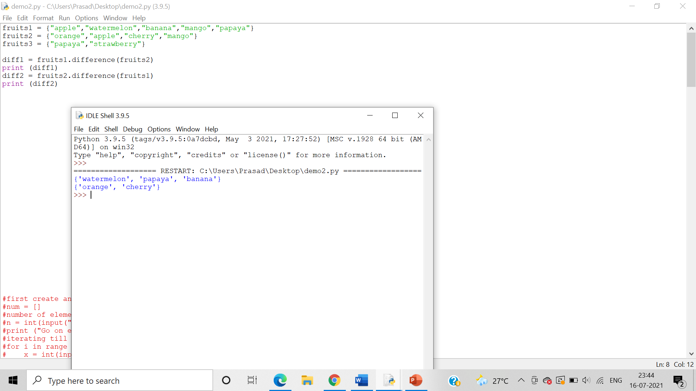

Program for demonstrating update()

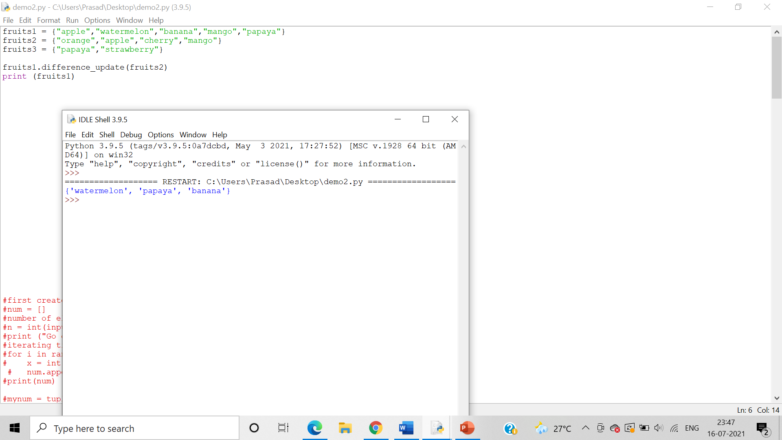

Program for demonstrating difference_update()

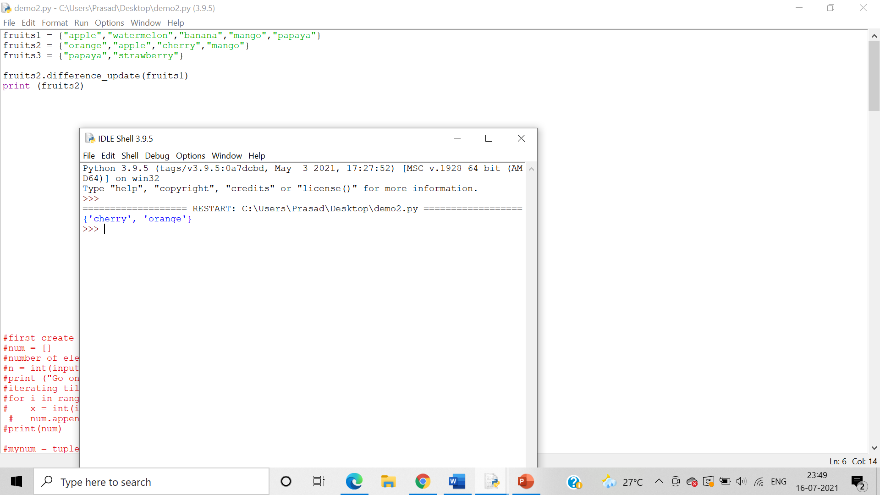

Program for demonstrating intersection()

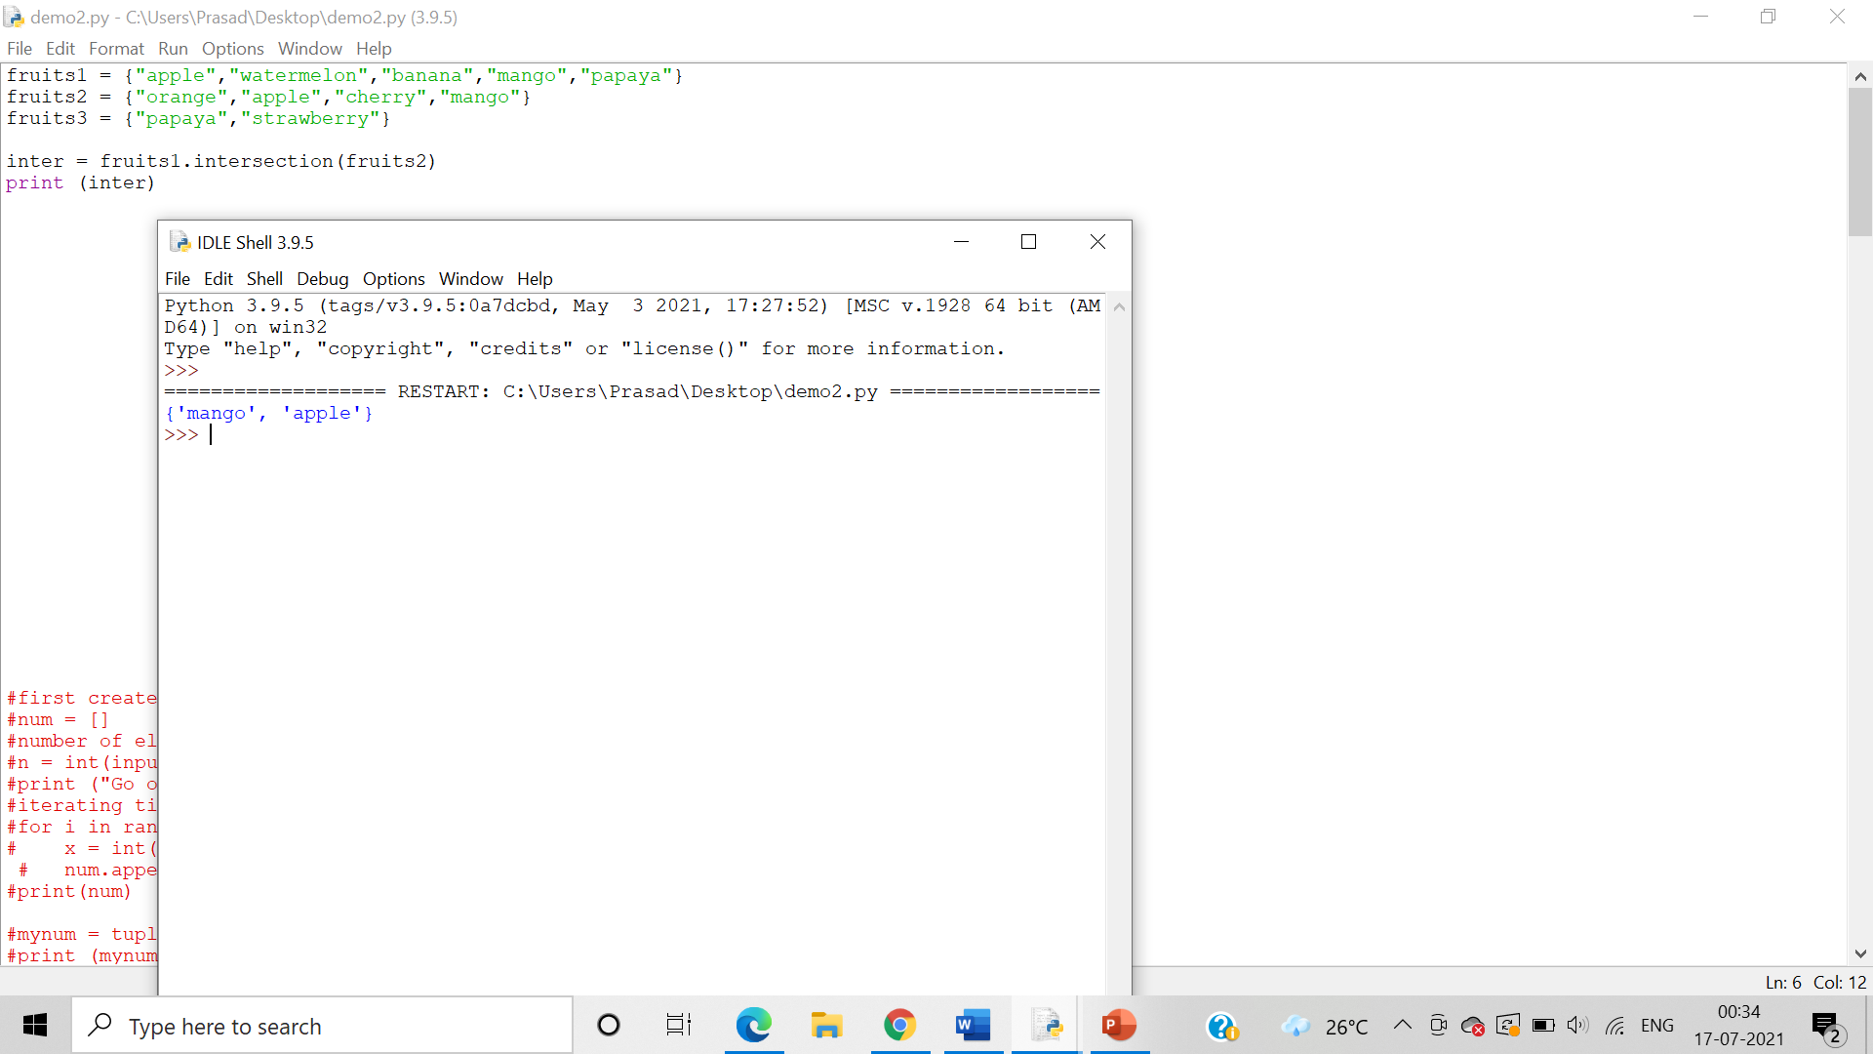

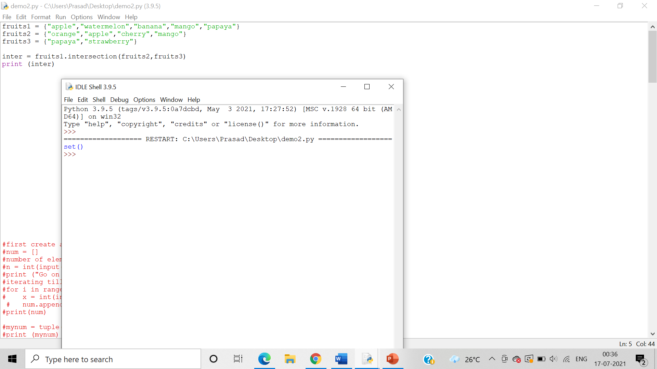

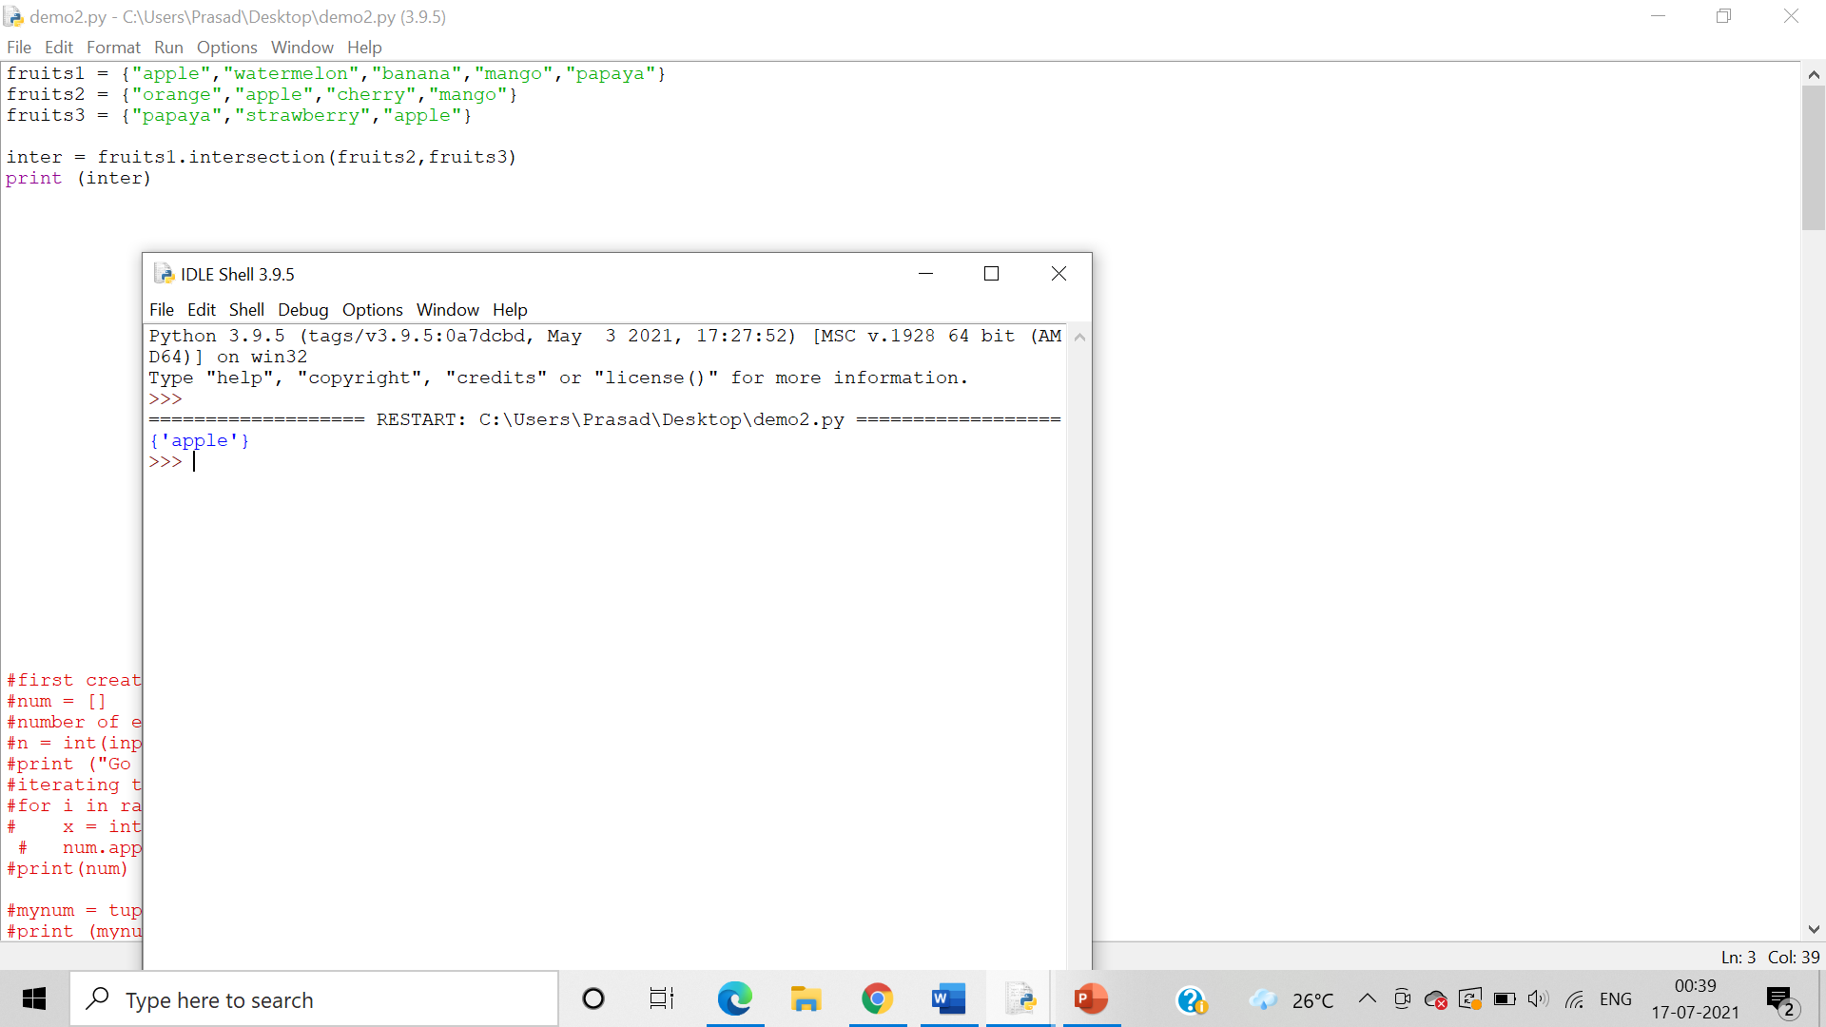

Program for demonstrating intersection_update()

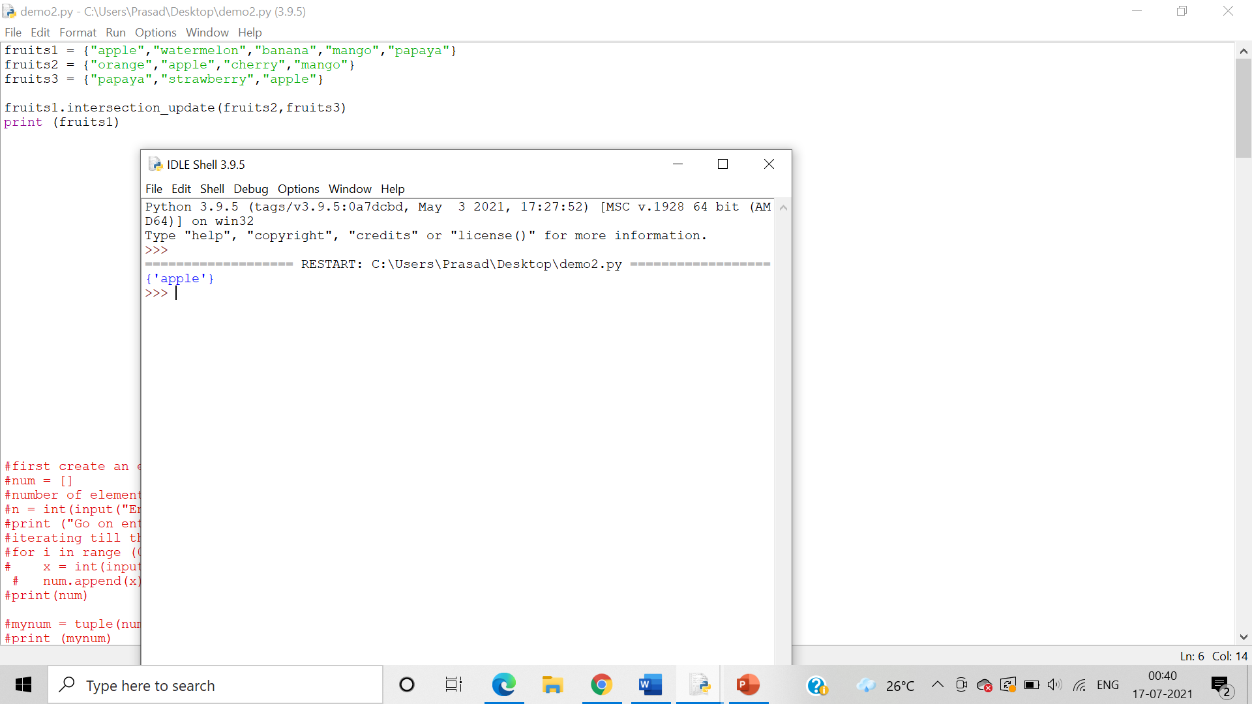

Program for demonstrating isdisjoint()

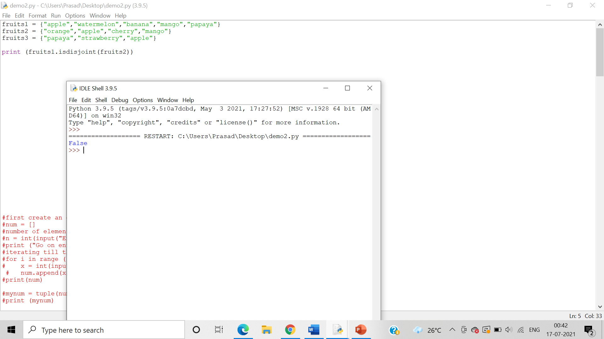

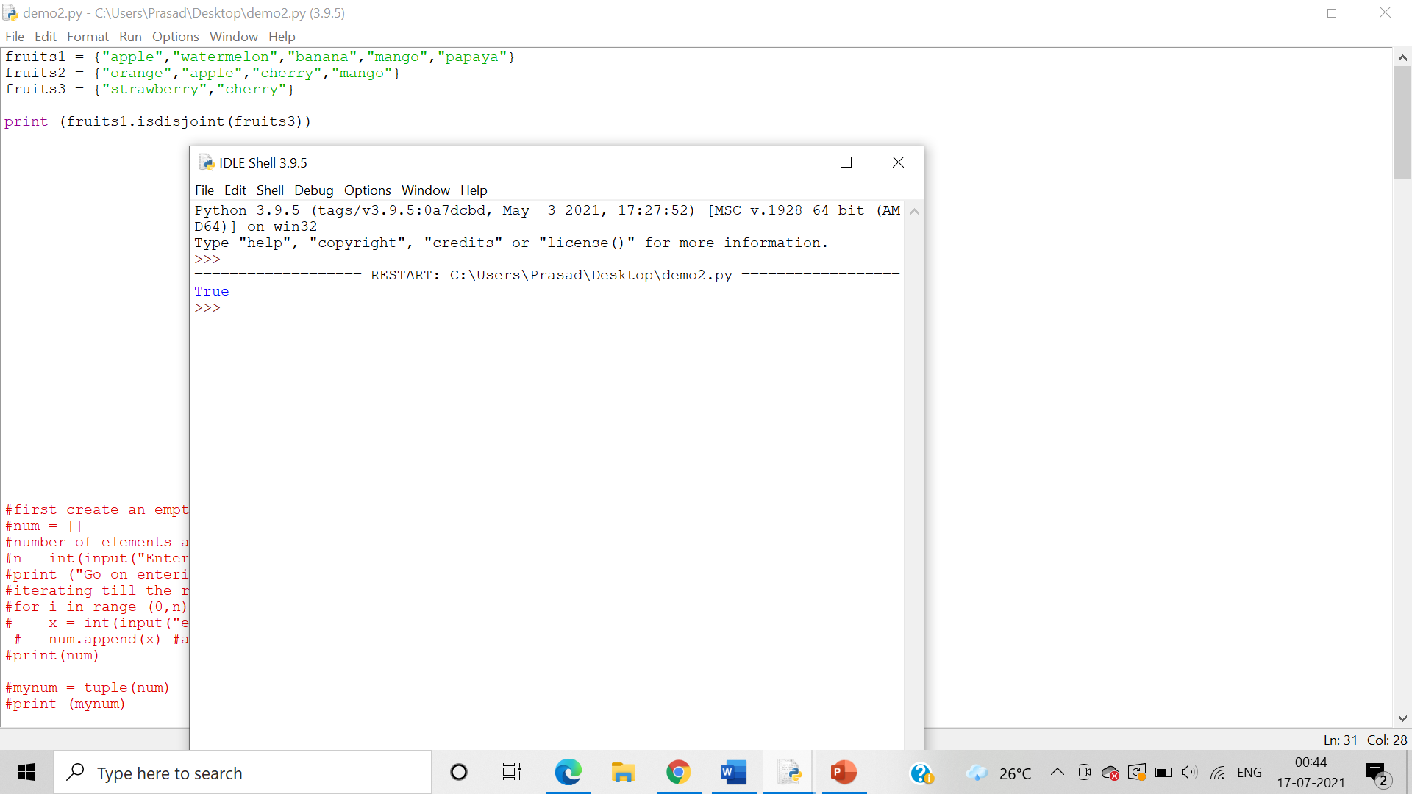

Program for demonstrating issubset()

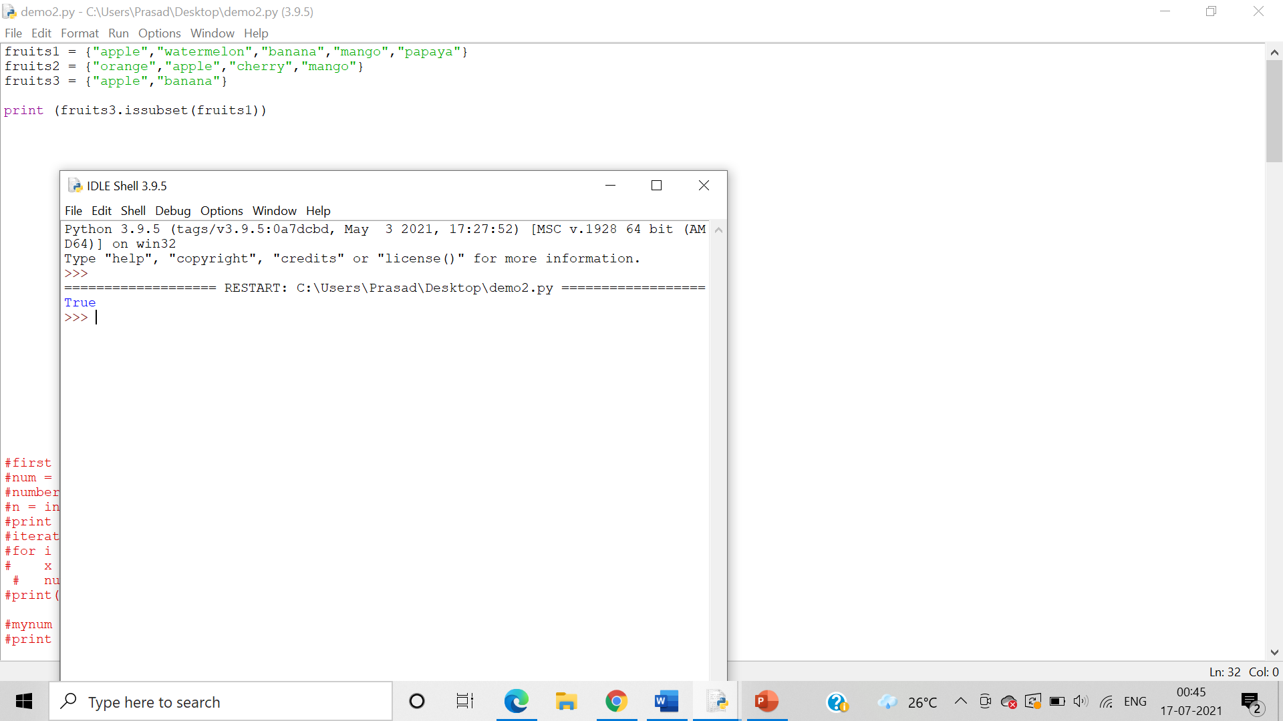

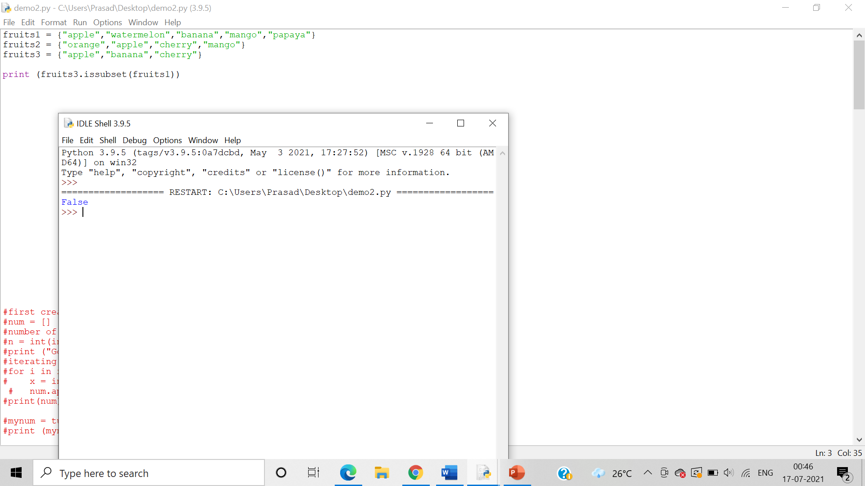

Program for demonstrating issuperset()

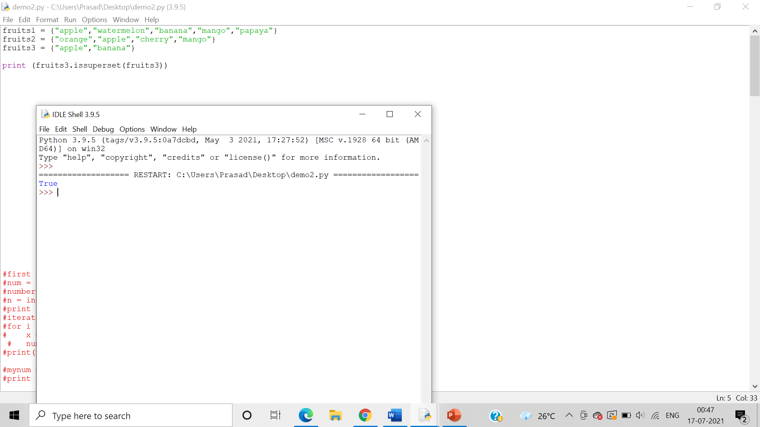

Program for demonstrating symmertic_difference()

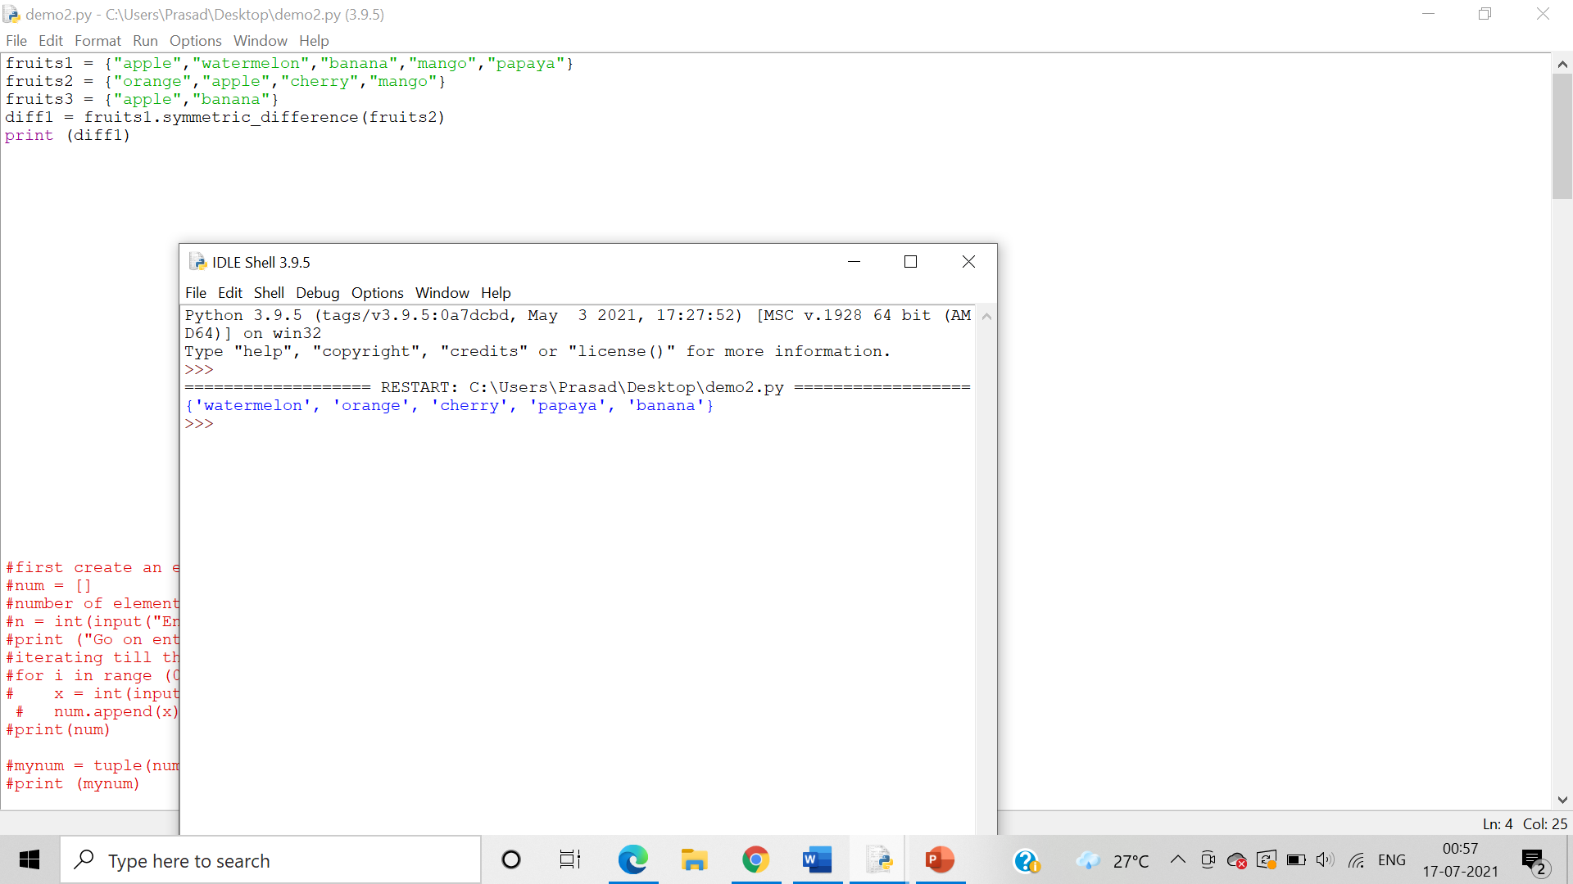

Program for demonstrating symmertic_difference_update()

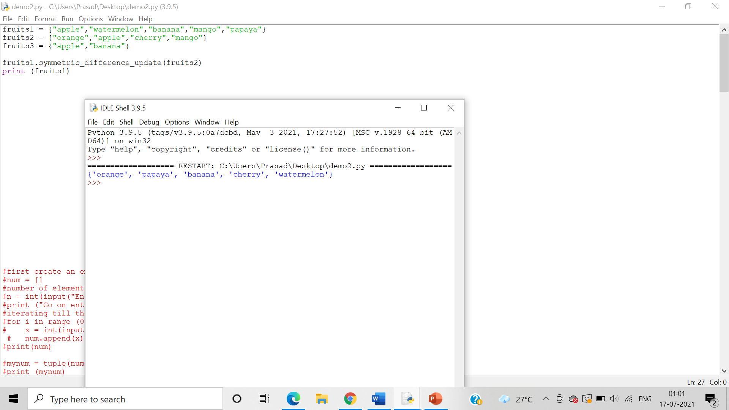

Program for demonstrating union()

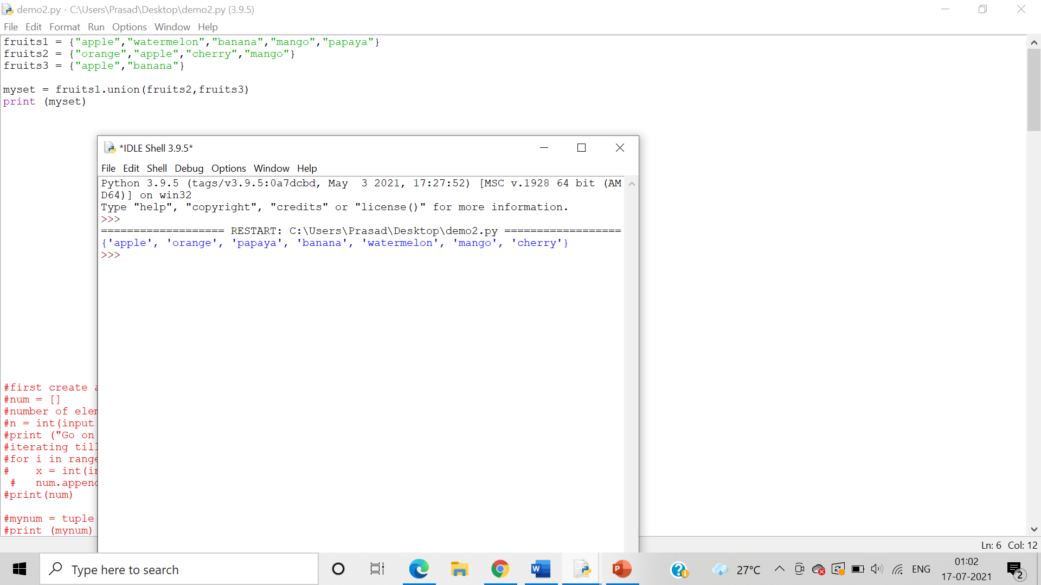

Program for demonstrating update()

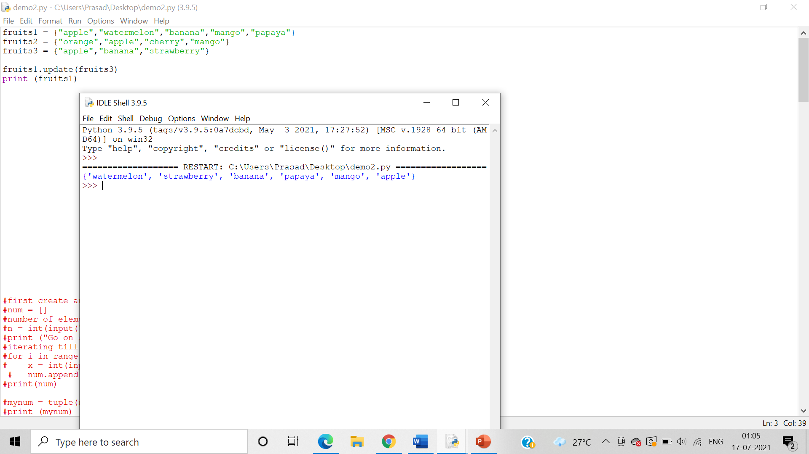

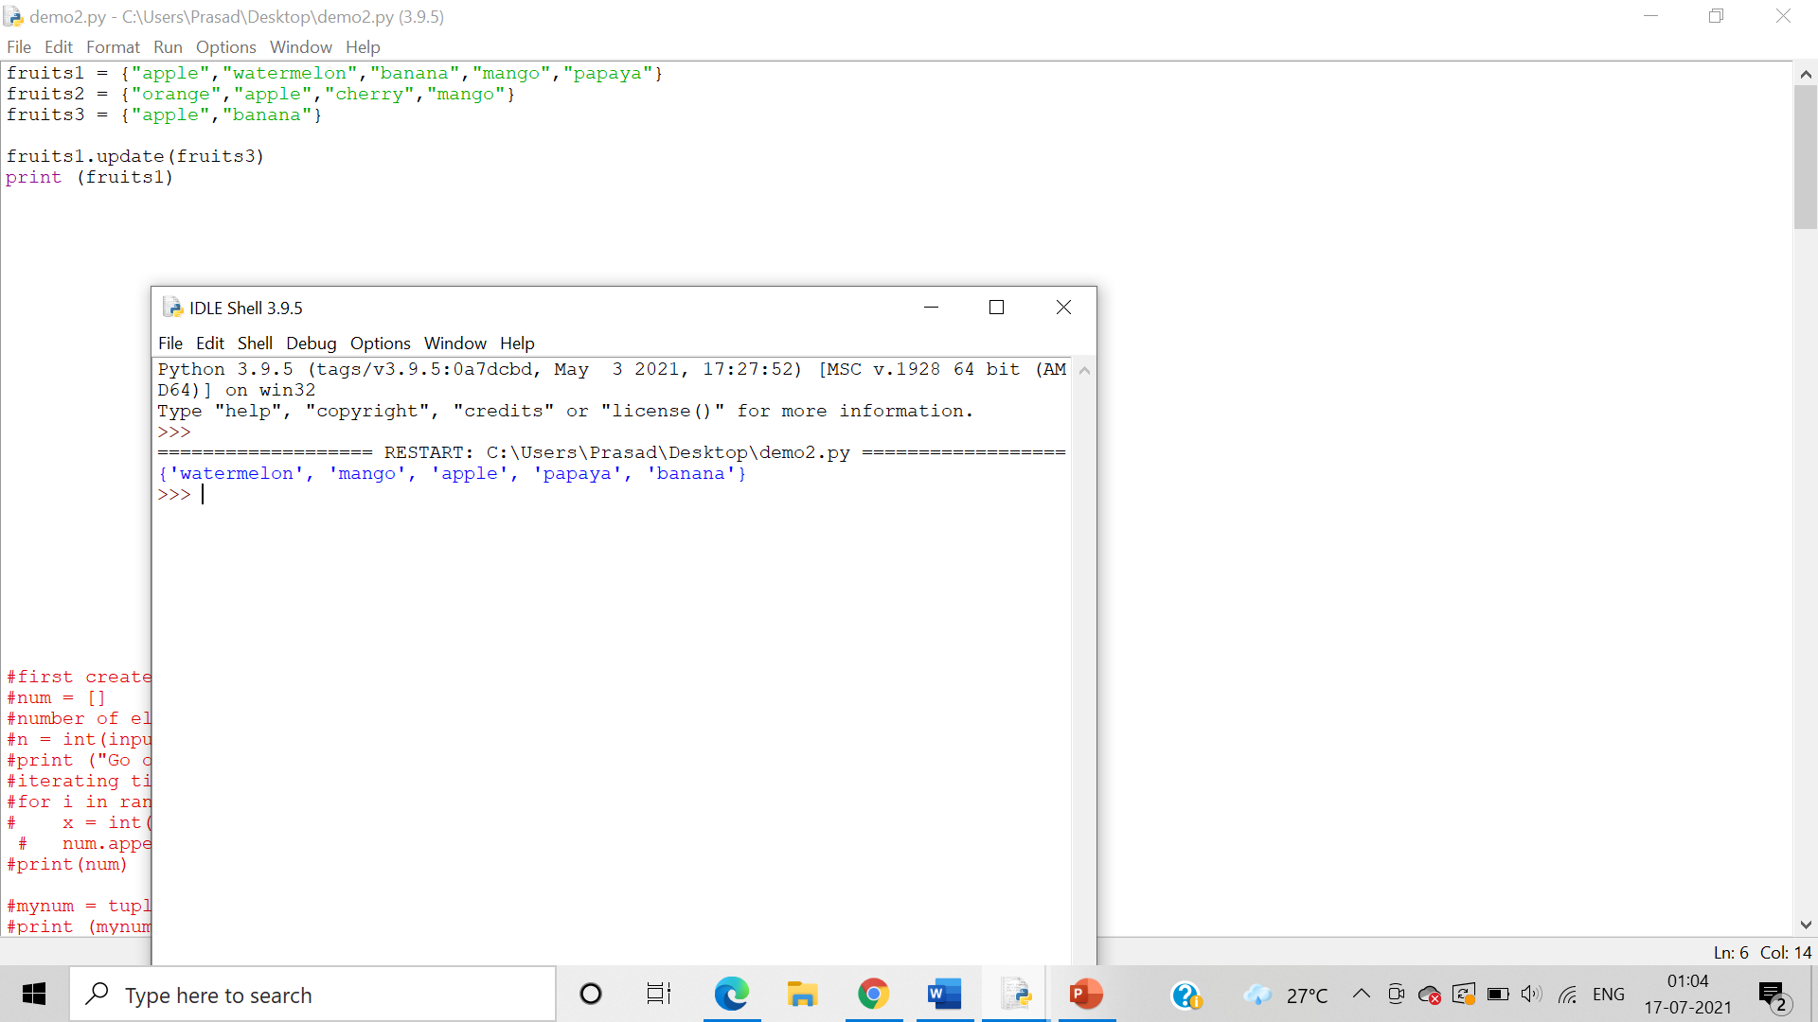

12.  Demonstrate declaration and usage of frozen sets

Answer: Program for declaration and usage of frozen sets

